Place for digital. sign of Revisor
Place for digital. sign of Contractor

00 | First issue | Antonio Aleksić | Grga Kolić | Zvonimir Lažeta |  | 17.8.2026.
Rev. | Revision Description | Created by | Checked by | Approved by Designer | Approved by Contractor | Date
Document Nr (CSD) PER-E-8-U5-MAN-001-00-VHHR

Employer:   | Consultant:   |   Contractor:  VOITH HYDRO GmbH&CoKG,  St. Pölten
Project:
Reconstruction and Modernisation
of HPP Perućica - Phase II
Title:
Unit 5 process control cubicle +U5CJA10 - Operating and maintenance instructions
  Designer: | Document No.: | Designer's No.:
 | PERU-01-15-170-70-001 | 22044-DD-EE-08-05-401

Table of contents
1 Unit process control cubicle 3
1.1 Equipment overview 3
1.1.1 Control system devices 10
2 Process control 11
2.1 Start diagram – manual mode 11
2.2 Start diagram – automatic mode 14
2.3 Normal shutdown 17
2.4 Quick shutdown 19
2.5 Emergency shutdown 21

Unit process control cubicle
“Unit process control” cubicle is used for control of the auxiliary processes, protection and monitoring of the unit. Process control includes generator cooling, transformer cooling, 110kV equipment control, and synchronization control. It is also used for automatic starting and stopping of the unit which includes issuing of the commands and setpoints to the turbine governor and excitation systems.

Equipment overview
Figure 1.1 shows the +U5CBC10 cubicle door layout while Table 1.1 contains its elements and their brief description.

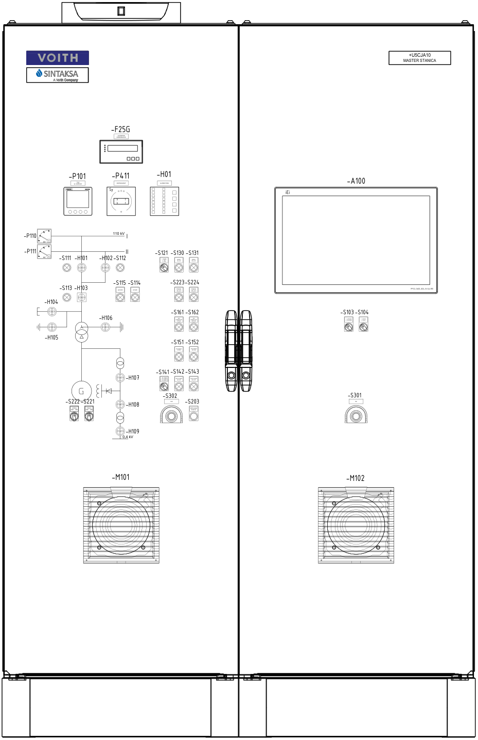
Figure 1.1. +U5CJA10 cubicle door layout11
Table 1.1 Cubicles outdoor elements
Label | Name | Description
-A100 | Operating panel (HMI) | This HMI device allows operator to change parameters and to monitor and control the entire process. It also indicates warnings and errors when they occur. Detailed instructions for operating with the operating panel are described in the “HMI Operating panel manual” document.
-S103 | 2 position switch:  Local – Remote | Switch positions:  - Local – Local control mode is activated. Unit control system receives commands and setpoints from operator via operating panel or from the pushbuttons located at the cubicle’s doors.  Remote – Remote control mode is activated. Unit control system receives commands and setpoints from superior control system, e.g. SCADA system.
-S104 | 2 position switch:  Manual – Automatic | Switch positions:  Manual – When manual control is selected, starting and stopping of the unit needs to be done manually by the operator.  Automatic – When automatic control is selected, starting and stopping of the unit will be done automatically by the control system.
-S301 | Pushbutton with indication – Emergency shutdown | This “mushroom” pushbutton is used to initiate emergency shutdown of the unit. The red indication light lights up when the emergency shutdown is active.
-F25G | Automatic synchronizer | The device used for automatic synchronization used for three-phase AC generators, provides automatic frequency, phase and voltage matching using analog or discrete output bias signals.
-P101 | Measuring device – main  Sentron PAC 3220 | A measuring device used for electrical measurements.
-P411 | Synchronoscope | It is used for manual synchronization with output contact.
-H01 | Alarm system | Device that is used to display main warnings and alarms.
-S111 | Pushbutton with indication | This pushbutton is used to operate disconnector 1.
-H101 | Position indicator | This device is used for signalization of the disconnector 1 state.
-H102 | Position indicator | This device is used for signalization of the disconnector 2 state.
-S112 | Pushbutton with indication | This pushbutton is used to operate disconnector 2.
-S121 | 3 position switch:  Manual – Test – Auto | Switch positions:  Manual – Manual synchronization selected.  Test – Test synchronization mode is activated. In this mode it is possible to check synchronization devices but closing of the circuit breaker is disabled.  Auto – Automatic synchronization is selected.
-S130 | Pushbutton - SYNCHRONIZATION ON | When all conditions are met, this button is used to start the synchronization process.
-S131 | Pushbutton - SYNCHRONIZATION OFF | When manual synchronization is active, this push button is used to deactivate it.
-S113 | Pushbutton with indication | This pushbutton is used to operate generator circuit breaker.
-H103 | Position indicator | This device is used for signalization of the generator circuit breaker state.
-S114 | Pushbutton – OPEN | This pushbutton is used to open circuit breaker or disconnectors, based on what is previously selected.
-S115 | Pushbutton – CLOSE | This pushbutton is used to close circuit breaker or disconnectors, based on what is previously selected.
-S223 | Pushbutton – EXCITATION ON | This pushbutton is used to start excitation system.
-S224 | Pushbutton – EXCITATION OFF | This pushbutton is used to stop excitation system.
-H104 | Position indicator | This device is used for signalization of the braking disconnector state.
-H105 | Position indicator | This device is used for signalization of the braking earth switch state.
-H106 | Position indicator | This device is used for signalization of the transformer neutral point disconnector state.
-S161 | Pushbutton – Generator cooling water valve - OPEN | This pushbutton is used to open generator cooling water valve.
-S162 | Pushbutton – Generator cooling water valve - CLOSE | This pushbutton is used to close generator cooling water valve.
-S151 | Pushbutton – Transformer cooling water valve - OPEN | This pushbutton is used to open transformer cooling water valve.
-S152 | Pushbutton – Transformer cooling water valve - CLOSE | This pushbutton is used to close transformer cooling water valve.
-S141 | 3 position switch:  Transformer pump 1 – Transformer pump 2 – Transformer pump 1 + 2 | Switch positions:  Transformer pump 1 – Transformer pump 1 is selected.  Transformer pump 2 – Transformer pump 2 is selected.  Transformer pump 1 + 2 – Both transformers pumps selected.
-S142 | Pushbutton – Transformer oil pump - ON | This pushbutton is used to start transformer oil pump.
-S143 | Pushbutton – Transformer oil pump - OFF | This pushbutton is used to stop transformer oil pump.
-S221 | 3 position switch:  Turbine:  Lower – Higher | Change positions:  ·Lower: Decreases the turbine governor setpoint.  ·Higher: Increases the turbine governor setpoint.
-S222 | 3 position switch:  Excitation:  Lower – Higher | Change positions:  ·Lower: Decreases the excitation system setpoint.  ·Higher: Increases the excitation system setpoint.
-S302 | Pushbutton with indication – CO2 | This “mushroom” pushbutton is used to initiate releasing of the CO₂ in the case of the fire. It will also initiate emergency shutdown of the unit.
-S203 | Pushbutton – LAMP TEST | This pushbutton is used to test signalization on the cubicle’s door.
-M101,  -M102 | Fan and filter | Used for flow and filtration of the air inside the cubicle to increase the life expectancy of the devices inside of the cubicle.

Figure 1.2 show cubicle layout without door. Table 1.2 contains elements and their brief description.
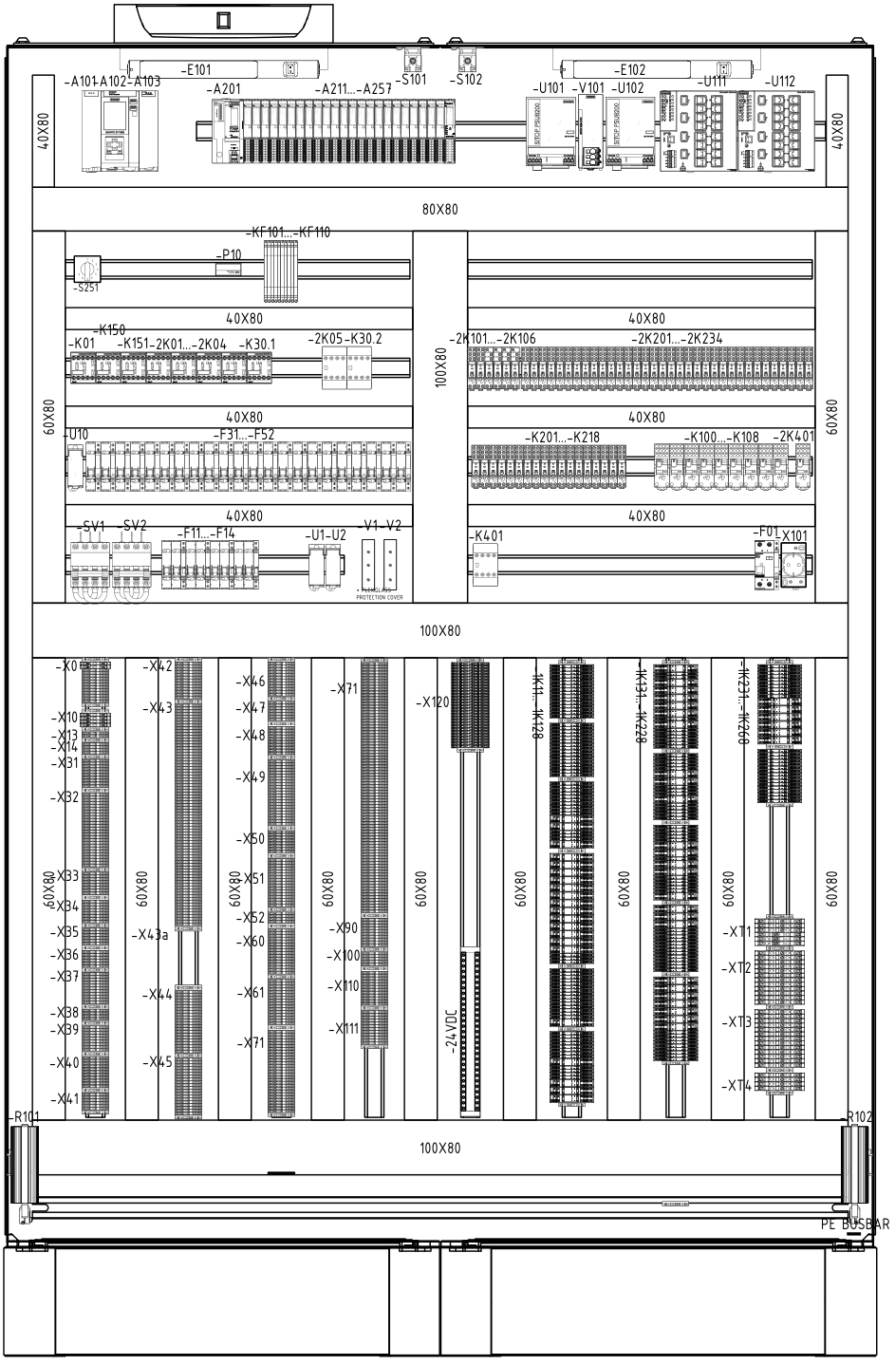
Figure 1.2. +U5CJA10 cubicle inside layout – front view12
Table 1.2 Indoor cubicles elements
Label | Name | Description
-A101 | Power supply | PLC (Programable logic controller) equipment - used to monitor, control and protect the unit.
-A102 | CPU
-A103 | Communication module
-A201 | IM (Interface module)
-A211,…,  -A226 | Digital input modules
-A231,…,  -A234 | Digital output modules
-A251,…,  -A257 | Analog input modules
-S101,  -S102 | Door contact | This limit switch is used to switch on lamp when cubicle’s doors are opened.
-U101,  -U102 | Power supply unit | Converts mains DC (220VDC) to low voltage regulated DC (24V) power.
-V101 | Redundancy module | Device that decouples parallel – switched power supplies.
-U111,  -U112 | Industrial ethernet switch | Links all the devices into one local network.
-E101,  -E102 | LED lights with on / off switch | Service light used to illuminate interior cubicles.
-B101 | Heater thermostat | The device is used for setting the air temperature value inside the cubicle under which the heater will switch on.
-B103 | Fan thermostat | The device is used for setting the air temperature value inside the cubicle under which the fan will switch on.
-B102 | Hygrostat | The device is used for setting relative air humidity value inside the cubicle above which the heaters will switch ON.
-S251 | 10 position switch | This switch is used to select which temperature measurement will be displayed on the -PT10.
-PT10 | Temperature display | This device is used to display temperature measurements.
-2K01…-2K05 | Contactor relay | Devices used to interrupt or establish connections in an electrical circuit repeatedly.
-2K101…-25106 | Auxiliary relay | The relays are used for galvanic isolation between the PLC output cards and the field signals or for the relay logic circuits inside of the cubicle (i.e. emergency stop circuit). These relays have 1 auxiliary contact.
-2K201…-2K117 | Auxiliary relay | The relays are used for galvanic isolation between the PLC output cards and the field signals or for the relay logic circuits inside of the cubicle (i.e. emergency stop circuit). These relays have 2 auxiliary contacts.
-2K118…-2K250 | Auxiliary relay | The relays are used for galvanic isolation between the PLC output cards and the field signals or for the relay logic circuits inside of the cubicle (i.e. emergency stop circuit). These relays have 2 auxiliary contacts.
-2K301 | Auxiliary relay | The relays are used for galvanic isolation between the PLC output cards and the field signals or for the relay logic circuits inside of the cubicle (i.e. emergency stop circuit). These relays have 4 auxiliary contacts.
-2K302 | Auxiliary relay | The relays are used for galvanic isolation between the PLC output cards and the field signals or for the relay logic circuits inside of the cubicle (i.e. emergency stop circuit). These relays have 4 auxiliary contacts.
-U10 | Distribution block | A Distribution block is used for distributing an electrical circuit from a single input source, to several devices in the branch circuit.
-F31…-F52 | 1-pole circuit breaker | It consists of 1 NO and 1 NC wire and if overload occurs, breaker will trip.
-K01 | Contactor relay | Devices used to interrupt or establish connections in an electrical circuit repeatedly.
-K201…-K217 | Auxiliary relay | The relays are used for galvanic isolation between the PLC output cards and the field signals or for the relay logic circuits inside of the cubicle (i.e. emergency stop circuit). These relays have 2 auxiliary contacts.
-K301…-K310 | Auxiliary relay | The relays are used for galvanic isolation between the PLC output cards and the field signals or for the relay logic circuits inside of the cubicle (i.e. emergency stop circuit). These relays have 4 auxiliary contacts.
-SV1,  -SV2 | Switch disconnector | Disconnector breaks the electrical circuit.
-F11…-F14 | 2-pole circuit breaker | It consists of 1 NO and 1 NC wire and if overload occurs, breaker will trip.
-U1,  -U2 | Distribution block | A Distribution block is used for distributing an electrical circuit from a single input source, to several devices in the branch circuit.
-V1,  -V2 | Diodes | Semiconductor device with two terminals, allowing a current to flow in one direction only.
-KF101…-KF110 | Pt100 converter | This device is used to convert Pt100 signal to 4-20 mA signal.
-F01 | Residual current circuit breaker (RCBO) | Safety devices with overcurrent protection that interrupts an electrical circuit when an imbalance is detected.
-X101 | Socket - outlet | Auxiliary socket.
-X | Terminals | Terminals for connecting wires and cables.
-1K11…-1K128 | Auxiliary relay | The relays are used for galvanic isolation between the PLC output cards and the field signals or for the relay logic circuits inside of the cubicle (i.e. emergency stop circuit).
-1K131…-1K228 | Auxiliary relay | The relays are used for galvanic isolation between the PLC output cards and the field signals or for the relay logic circuits inside of the cubicle (i.e. emergency stop circuit).
-1K231…-1K288 | Auxiliary relay | The relays are used for galvanic isolation between the PLC output cards and the field signals or for the relay logic circuits inside of the cubicle (i.e. emergency stop circuit).
-XT1,  -XT2,  -XT3,  -XT4 | Terminal block | Test disconnect terminal block.
-R101,  -R102 | Cubicle heaters | Heaters heat the air inside the cubicle to increase the life expectancy of the devices inside of the cubicle.

Control system devices
In this chapter the operating functions, modes and parameters of the devices inside the cubicles will be described.

-A101 …, -A257 – PLC – The configuration of this device is modular and different for each power plant. In each of its operating cycles, the device first determines the state of the process and checks for a fault by reading digital and analog inputs. If there are no active alarm states, its algorithm is used to determine further actions performed by the device digital and analog outputs and communication protocols. If any alarm state is active, it notifies the operator by displaying alarms on the operating panel and initiating unit shutdown if necessary. For better insight of the state of the process, the flow of information can be established with other devices of the control system using a specific communication protocol. Different PLC models with appropriate modules can be used. A detailed device description can be found in the manufacturer operating manual.

-B101, -B103 – Thermostat – Used thermostat is Alfa Electric THR2 thermostat. By switching on the dry contact 1-2, cubicle heaters are switched on. The temperature setpoint for switching contact on and off can be changed with the potentiometer on the front side of the device. Initially the setpoint is set between 15°C and 20°C.

-B102 – Hygrostat – Used hygrostats is Fanndis hygrostat . Activates the heater and/or fan when a preset relative humidity inside the enclosure is exceeded. This raises the relative humidity above the dew point and prevents condensation on assemblies and electronic components.

-U111, -U112 – Industrial ethernet switch – These devices are used to link the control system devices to the local network.

Process control
Depending on the location and mode, there are different ways to control the process. Using 3-position switch on the manual control cubicle’s door, it is possible to switch between manual, semi-automatic and automatic mode. Using the 2-position switch, it is possible to select control location to local (HMI or pushbuttons on manual control cubicle) or remote (SCADA).

When manual control is selected, an operator manually executes all commands and sets all setpoints required for proper operation of the unit. When automatic control is selected, the control system requires only start and stop commands as well as the setpoint for the desired operating mode of the unit. According to the commands, the control system performs all the actions necessary to keep the unit at the desired setpoint.

When local control is selected, the control system accepts commands and setpoints from the pushbuttons on the cubicle and from the operating panel. Otherwise, when remote control is selected, the control system accepts commands and setpoints from the common control system or from the SCADA. In the local control mode, it is possible to control the process with the help of the pushbuttons on manual control cubicle even if the PLCs is not working.

WARNING: REMOTE CONTROL IS POSSIBLE ONLY IN AUTOMATIC MODE.

In this chapter, the unit control system is explained through flow diagrams and logic diagrams. Detailed descriptions of all states, measurements, indications and actuators can be found in the “HMI operating panel manual”.

Start diagram – manual mode
For system operation in the manual mode, local / remote switch must be in the “Local” position and “Manual” mode must be selected on the 3-position switch. To start the unit, there must be no alarm that causes starting interlock or shutdown, and the unit must be in standstill state. The flow diagram of the normal start in manual mode is shown in Figure 2.1.

Figure 2.1. Manual mode start flow diagram – process control as a block diagram

Sequence steps while starting in manual mode are following:
- UNIT AT REST - The unit is in the resting state and control system is waiting for the starting conditions to be fulfilled.

- TRANSFORMER AND GENERATOR COOLING CONTROL – During this step, transformer oil pump is switched on and transformer water valve and generator transformer water valve are opened.

- BUSBAR DISCONNECTORS CONTROL – During this step, one of the two 110 kV disconnectors is closed.
- EXCITATION – During this step, excitation system is started.
  - The control system proceeds to the next step when the unit speed and generator voltage are at the required values.

- NO LOAD – The generator voltage is built and generator is running in no-load mode. When the command for synchronization is generated, by pressing the pushbutton -S131, synchrocheck -P411 and automatic synchronizer (only if automatic synchronization is selected (-S121 switch)) are switched on. Synchronization can be switched off in any moment by pressing the -S130 pushbutton.

- SYNCHRONIZATION: The generator circuit breaker is enabled. If automatic synchronization is selected, the automatic synchronizer generates signals to increase/decrease the generator speed and voltage and command to close the GCB when the conditions for synchronization are fulfilled. Otherwise, if manual synchronization is selected, an operator must generate signals to increase/decrease generator speed and voltage using -S251 and -S252 switches. Also, when synchrocheck -P411 signalize that conditions are fulfilled (green LED), the operator must generate a command to close the GCB using the -S231 pushbutton. After successful synchronization, starting sequence is finished.

Start diagram – automatic mode
To operate the unit in automatic mode, “Automatic” mode must be selected on the HMI panel. Depending on the desired control location, the switch can be set to “Local” or “Remote”. If remote control is selected, the control system receives commands and setpoints from common control system or SCADA. If “Local” control is selected, the control system receives commands and setpoints from the operating panel, switches and pushbuttons on the cubicle. To start the unit, there must be no alarm that causes starting interlock or shutdown and the unit must be in standstill state. The flow diagram of the normal start in automatic mode is shown on Figure 2.2.
Figure 2.2. Automatic mode start flow diagram – process control as a block diagram
Sequence steps while starting in automatic mode are following:
- UNIT AT REST- the unit is in resting state and there is no active start command.
  - Either by pressing the START button, or by the operating panel on the cubicle door when local control is selected, or by the superior system when the remote control is selected, with all start conditions fulfilled, the start sequence for normal start in automatic mode is activated.

- TURBINE GOVERNOR – During this step, the operator activates the turbine start-up sequence on the turbine governor. After the reached speed is higher than the minimum speed required to start the excitation, control system proceeds to the next step.

- TRANSFORMER AND GENERATOR COOLING CONTROL – During this step, transformer oil pump is switched on and transformer and generator cooling water valves are opened.

- BUSBAR DISCONNECTORS CONTROL – During this step, one of the two 110 kV disconnectors is closed.

- EXCITATION: During this step, excitation system is started.
  - The control system proceeds to the next step when the unit speed and generator voltage are at the required values.

- NO LOAD – The generator voltage is built and the generator is running in no-load regime. When the start synchronization command is generated, synchrocheck -P411 and automatic synchronizer are turned on.

- SYNCHRONIZATION – In this step automatic synchronizer generates signals to increase/decrease the generator frequency and voltage, and a command to close the GCB when conditions for synchronization are fulfilled. After successful synchronization, starting sequence is finished.

Normal shutdown
Flow chart of normal shutdown is shown in Figure 2.3
Figure 2.3 Normal shutdown flow diagram

Sequence steps during normal shutdown of the unit are:

- HPP ONLINE – GCB is closed and the generator produces electrical energy.
  - By pressing the “Stop” pushbutton on the door of the “Process control” cubicle or “STOP” button on the operating panel when local control is selected or by receiving the “Stop” command from superior control system when the remote control is selected, the stop command is generated.

- MINIMAL ACTIVE POWER – In this step generator circuit breaker is opened after control system receives signal that the generator active power has fallen below the generator active power limit set to open the generator circuit breake from the turbine governor.
  - The control system proceeds to the next step when generator circuit breaker is open.

- NO LOAD – After generator circuit breaker is open, command to open the disconnector is generated. Also, a command for switching off excitation system is generated.
  - When the disconnector is opened, and excitation is switched off, the control system proceeds to next step.
- CLOSING TURBINE – In this step control system waits until turbine is completely closed.
  - After turbine is completely closed, control system proceeds to the next step.
- BRAKING – A command for starting the electrical braking is generated from the Excitation cubicle.
  - To proceed to the next step, the speed must be below electrical brake stop limit.
- UNIT AT REST – Commands for switching off the transformer oil pump, closing the transformer and generator cooling water valve are generated. Also, a command for stopping the electrical braking is generated from the Excitation cubicle.

Quick shutdown
Quick shutdown is a sequence with the priority to bring a unit to a standstill as soon as possible due to a mechanical fault. The speed of the unit must not increase above the speed at the time of the fault, otherwise the fault could get worse and severe mechanical damage may occur. Quick shutdown can be activated regardless of the operating mode of the HPP. It can be activated by certain alarm states or by superior control system.

Figure 2.4 Quick shutdown flow diagram

Sequence steps during quick shutdown of the unit are:

- HPP ONLINE – The GCB is closed and the generator produces electrical energy.
  - The quick shutdown command is generated when the system enters one of the alarm states from the alarms group that is quick emergency shutdown.

- MINIMAL ACTIVE POWER – The turbine governor cubicle closes all nozzles and deflectors with highest possible speed.
  - The sequence continues when the system gets the signal from the turbine governor cubicle that the generator active power has fallen below the generator active power limit set to open the generator circuit breaker, and when the generator circuit breaker is open.

- NO LOAD – The command to open the disconnector is generated. Also, the command for switching off excitation system is generated.
  - When the disconnector is opened and excitation system is switched off, the sequence proceeds to the next step.
- CLOSING TURBINE – In this step control system waits until turbine is completely closed.
  - After turbine is completely closed, control system proceeds to the next step.
- BRAKING – A command for starting the electrical braking is generated from the Excitation cubicle.
  - To proceed to the next step, the speed must be below electrical brake stop limit.
- UNIT AT REST – Commands for switching off the transformer oil pump, closing the transformer and generator cooling water valve are generated. Also, a command for stopping the electrical braking is generated from the Excitation cubicle.

Emergency shutdown
Emergency shutdown is a sequence with the priority to open the GCB and then bring the unit to a standstill as soon as possible due to fault. Emergency shutdown can be activated regardless of the HPP operating mode. The flow diagram of the emergency shutdown of the unit is graphically shown in Figure 2.5.

Figure 2.5 Emergency shutdown flow diagram

Sequences during electrical emergency shutdown:

- HPP ONLINE – The GCB is closed and the generator produces electrical energy.
  - The electrical emergency shutdown command is generated when the system enters one of the alarm states from the alarms group that is causing electrical emergency shutdown.

- OPEN GCB – Command for switching off generator circuit breaker is generated.
  - Sequence continues when the generator circuit breaker is open.

- CLOSING TURBINE – In this step control system waits until turbine is completely closed.
  - After turbine is completely closed, control system proceeds to the next step.
- BRAKING – A command for starting the electrical braking is generated from the Excitation cubicle.
  - To proceed to the next step, the speed must be below electrical brake stop limit.

- UNIT AT REST – Commands for switching off the transformer oil pump, closing the transformer and generator cooling water valve are generated. Also, a command for stopping the electrical braking is generated from the Excitation cubicle.

